Website: Athlete Store

**The Athlete Store**

# **Section # 01**

Introduction:  
Welcome to the Athlete Store – your ultimate destination for premium sports gear and apparel! Whether you're a seasoned athlete or just starting your fitness journey, we have everything you need to boost your performance. Our curated selection includes high-quality products from top brands, ranging from premium running shoes to cutting-edge fitness trackers. What sets us apart is our unwavering commitment to quality, durability, and style, ensuring athletes receive nothing but the best. Whether you're a runner, weightlifter, yogi, or team sports enthusiast, Athlete Store has you covered with a user-friendly online platform for easy shopping. Join our community today, gear up for success, and unleash the athlete in you with products that seamlessly blend performance, comfort, and style. Your journey to peak athletic performance begins here!

Domain Introduction:

Welcome to our Athlete Website, your digital haven for all things sports! Whether you're a seasoned athlete or just starting out, we're here to inspire and equip you. Explore a curated selection of top-quality sports gear and discover insightful articles on training techniques. Our mission is to empower athletes of all levels, fostering a supportive online community where passion and expertise converge. From engaging stories to the latest athletic products, we've got you covered. Join us in celebrating the joy of fitness, the spirit of teamwork, and the pursuit of excellence. Your journey to peak performance starts right here at the Athlete Website. Welcome aboard!

Motivation:

The motivation behind designing an Athlete Store could stem from several compelling factors:

* **Passion for Sports:** Genuine love for athletics and a desire to share that enthusiasm.
* **Quality Performance Products:** Providing high-quality gear to enhance athletic performance.
* **Community Building:** Fostering a sense of community among like-minded athletes.
* **Innovation and Trends:** Staying at the forefront of sports technology and fashion trends.
* **Empowerment and Inspiration:** Helping individuals achieve their fitness goals and inspiring them along the way.
* **Gap in the Market:** Identifying and addressing specific needs in the sports retail market.
* **Entrepreneurial Drive:** Building and establishing a brand in the sports and fitness industry.
* **Global Accessibility:** Offering athletes worldwide easy access to diverse sports products online.

Scope:

* **Product Diversity:** Expand the range of sports gear and apparel to cater to various sports and fitness activities.
* **Specialization:** Focus on a niche market or specific sports gear category for a unique identity.
* **Global Reach**: Utilize online platforms for international accessibility and adapt to regional preferences.
* **Collaborations:** Partner with athletes, influencers, or fitness experts to enhance brand credibility.
* **E-commerce Innovations:** Incorporate virtual try-ons, personalized recommendations, and interactive features.
* **Community Engagement:** Foster an active online community through forums, social media, and virtual events.

Objectives:

* **Customer Satisfactio**n**:** Prioritize a positive shopping experience, focusing on customer needs, efficient service, and post-purchase support.
* **Product Excellence:** Curate a premium selection of sports gear, emphasizing quality, durability, and contemporary design.
* **Market Expansion:** Increase the store's reach and market share by targeting diverse customer segments and exploring international markets.
* **Brand Recognition:** Build a strong brand identity through consistent messaging, impactful marketing, and positive customer interactions.
* **E-commerce Optimization:** Continuously enhance the online platform, integrating user-friendly features, innovative technologies, and robust security measures.
* **Community Engagement**: Foster an active online community, encouraging discussions, sharing experiences, and creating a sense of belonging among athletes and fitness enthusiasts.

Technologies:

The technologies employed by an Athlete Store can span various aspects of e-commerce, online presence, and customer engagement. Here are key technologies that can contribute to the success of an Athlete Store:

* **E-commerce Platform:** Utilize robust e-commerce platforms such as Shopify, WooCommerce, or Magento for seamless online store management, order processing, and inventory control.
* **Responsive Web Design:** Implement responsive design principles to ensure an optimal user experience across various devices, including desktops, tablets, and smartphones.
* **Secure Payment Gateways**: Integrate secure and widely-used payment gateways like PayPal, Stripe, or Square to facilitate safe and convenient transactions.
* **Content Management System (CMS**): Employ a CMS like WordPress to easily manage and update website content, product listings, and blog posts.
* **Customer Relationship Management (CRM):** Implement CRM systems such as Salesforce or HubSpot to manage customer interactions, track purchases, and personalize marketing efforts.
* **Data Analytics Tools:** Utilize tools like Google Analytics or Adobe Analytics to gather insights into customer behavior, website performance, and marketing effectiveness.
* **Social Media Integration:** Leverage social media platforms and integrate sharing functionalities to expand the store's reach and encourage social engagement.
* **Email Marketing Platforms**: Employ email marketing tools like Mailchimp or Klaviyo to create targeted campaigns, newsletters, and personalized communications with customers.
* **Augmented Reality (AR**): Explore AR technologies for virtual try-ons, allowing customers to visualize products before making a purchase.
* **Chatbots:** Implement chatbots powered by AI to provide real-time customer support, answer queries, and assist with the purchasing process.
* **Mobile Apps:** Consider developing a dedicated mobile app to enhance the mobile shopping experience, send push notifications, and foster customer loyalty.
* **Cloud Hosting:** Opt for cloud hosting services like AWS, Azure, or Google Cloud for scalability, reliability, and efficient data management.
* **Security Measures:** Implement SSL certificates, encryption protocols, and secure sockets layer (SSL) to ensure the security of customer data and transactions.
* **Virtual Events Platforms:** Host virtual events or webinars using platforms like Zoom or Microsoft Teams to engage the community and promote products.
* **Shipping and Logistics Software**: Use shipping and logistics solutions like ShipStation or Shippo for streamlined order fulfillment and shipment tracking

By leveraging these technologies, an Athlete Store can enhance its online presence, improve customer interactions, and stay competitive in the dynamic e-commerce landscape.

# **Section # 02**

**ER DIAGRAM:**

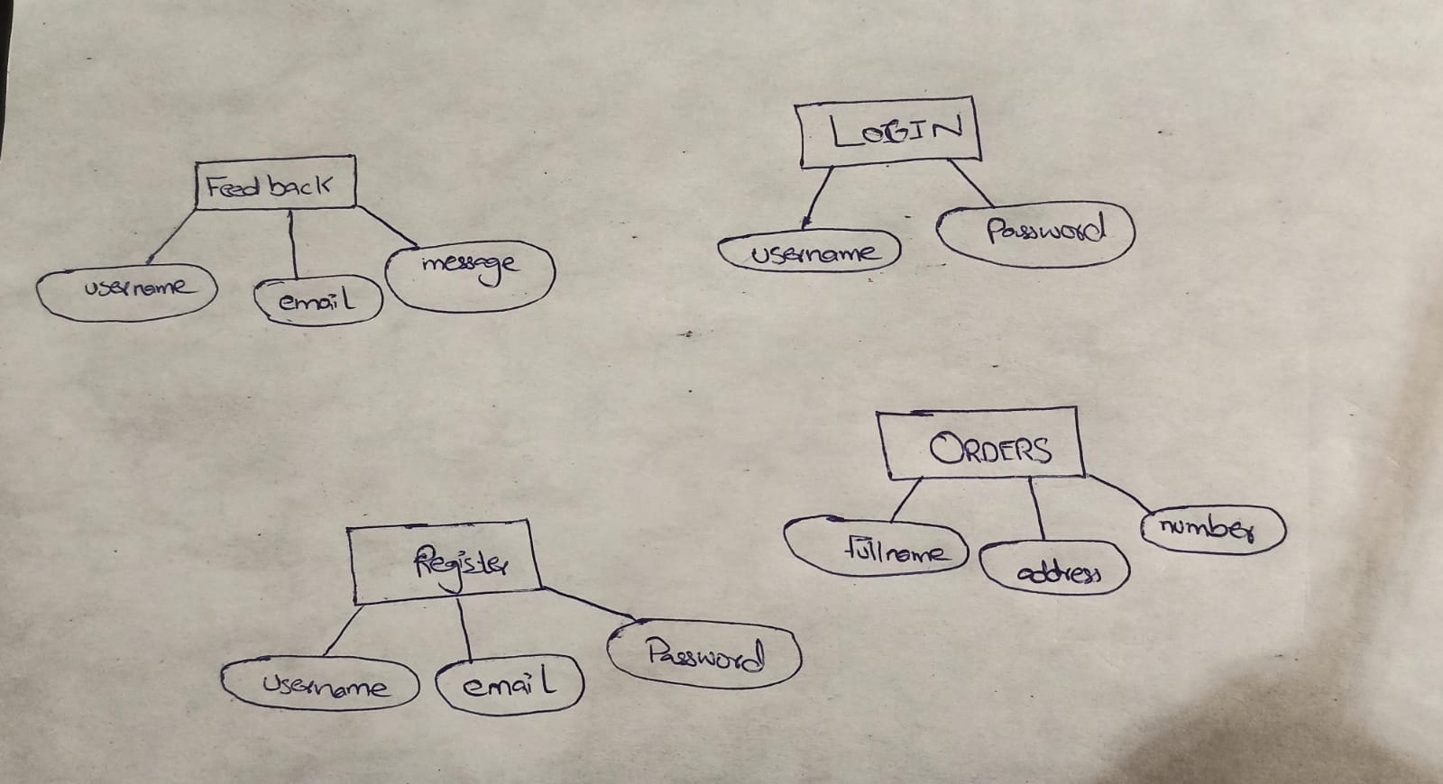

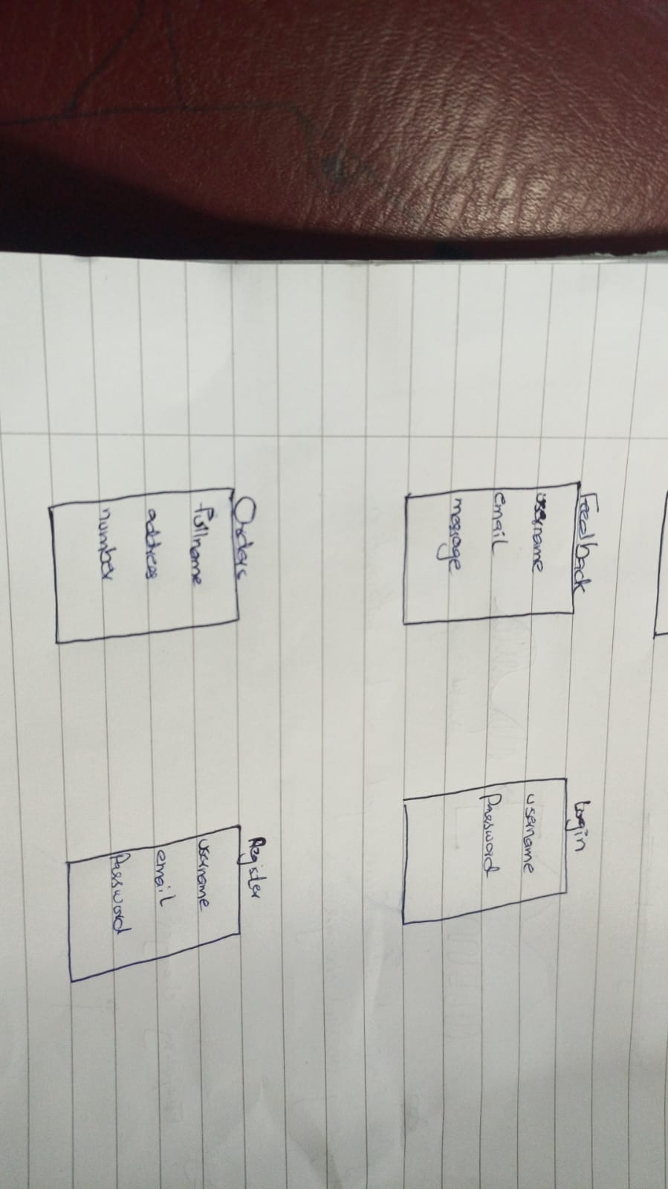

1. Table “feedback”:

Attributes:

* “username` (Type: VARCHAR): Represents the username associated with the feedback.
* “email` (Type: VARCHAR): Represents the email address of the user providing feedback.
* “message` (Type: VARCHAR): Contains the actual feedback message from the user.

2. Table `login`:

Attributes:

1. “username”(Type: VARCHAR [Primary Key]):** Represents the username used for logging in. It is also the primary key, ensuring its uniqueness.

2. “password” (Type: VARCHAR): Stores the password associated with the login username.

3. Table `register`:

Attributes:

1. “username”(Type: VARCHAR [Primary Key]): Represents the username chosen by a user during the registration process. It is the primary key, ensuring its uniqueness.

2. “email”(Type: VARCHAR):Stores the email address provided during the registration process.

3. “password” (Type: VARCHAR): Stores the password associated with the registered username.

4. Table `orders`:

Attributes:

1. “Fullname” (Type: VARCHAR): Represents the full name associated with an order.

2. ”number” (Type: VARCHAR): Represents a unique identifier or order number for tracking purposes.

3. “address” (Type: VARCHAR): Stores the address associated with the order, likely the delivery address.

Explanation:

“VARCHAR”: This datatype is used to store variable-length character strings (text). The length can vary based on the specific requirements.

“[Primary Key]”: Indicates that the associated attribute is the primary key for the table. A primary key is a unique identifier for each record in the table.

# 

# 

# **Section # 03**

Implementation

**Main Page:**

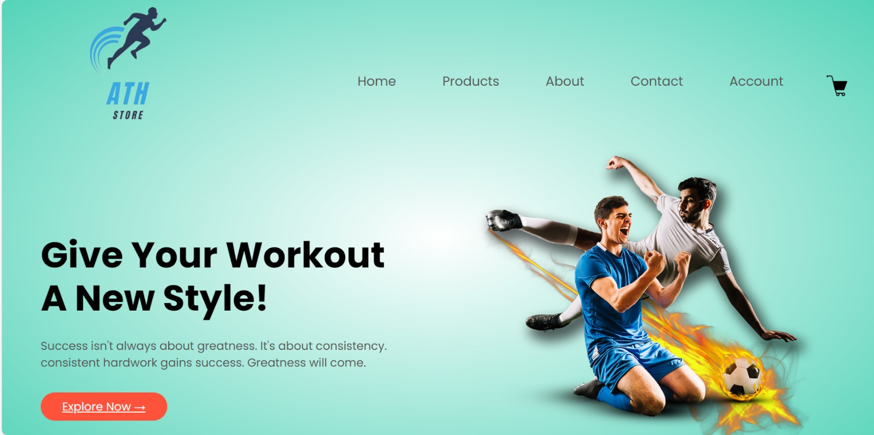

**Explanation:**

1. **Head Section:**
   * Meta tags for character set and viewport.
   * Title of the website.
   * External stylesheets (CSS) and font links.
2. **Body Section:**
   * **Header:**
   * Navbar with a logo, navigation links, and a shopping cart icon.
   * Two columns with a slogan, introductory text, and an explore button.
   * An image column displaying a football player.
   * **Featured Categories:**
   * Display of featured category images in a row.
   * **Featured Products:**
   * Display of featured products with images, product names, ratings, and prices.
   * Each product has a link to view details.
   * **Latest Products:**
   * Display of latest products with images, product names, ratings, and prices.
   * Each product has a link to view details.
   * **Special Offer:**
   * An exclusive offer section with an image, offer details, and a "Buy Now" button.
   * **Testimonial:**
   * Customer testimonials with quotes, ratings, and names displayed in a row.
   * **Footer:**
   * An image and a brief description of the store's purpose.
   * A horizontal line (hr) for visual separation.
   * Copyright information.
3. **External Resources:**
   * The website uses external resources like images, font-awesome icons, and an exclusive offer image hosted on GitHub.

**BACK END:**

**Contact Form Submission:**

**Explanation:**

* It includes the "connection.php" file, presumably containing the database connection code.
* Initializes variables for name ($namee), email ($email), and message ($messagee).
* Checks if the form is submitted using the isset($_POST['save']) condition.
* If the form is submitted, it retrieves data from the form fields.
* Inserts the data into the "feedback" table in the database using an SQL query.
* Redirects the user to "contactus.php" after the submission.

**User Login:**

**Explanation:**

* Similar structure to the first block, including the "connection.php" file.
* Initializes variables for username ($username) and password ($passwordd).
* Checks if the form is submitted.
* Retrieves data from the form fields and inserts it into the "loginn" table in the database.
* Redirects the user to "Account.php" after the submission.

**User Registration:**

**Explanation:**

* Similar structure to the previous blocks.
* Initializes variables for username ($usernamee), email ($emaill), and password ($passworddd).
* Checks if the form is submitted.
* Retrieves data from the form fields and inserts it into the "register" table in the database.
* Redirects the user to "Account.php" after the submission.

**Order Processing:**

**Explanation:**

* Similar structure as before.
* Initializes variables for full name ($fullname), phone number ($number), and address ($address).
* Checks if the form is submitted.
* Retrieves data from the form fields and inserts it into the "orders" table in the database.
* Redirects the user to "Account.php" after the submission.

All sections use the header('location: ...') function to redirect the user after processing the form. It's crucial to ensure that no output is sent to the browser before this function to avoid header-related errors.

The use of include("connection.php") suggests that there's a separate file (connection.php) responsible for establishing a database connection. The actual content of that file is not provided in your snippet.